A
SUMMER INTERNSHIP PROJECT
REPORT ON
"Interactive Food Delivery Analysis Dashboard using Microsoft Excel"
AT


WEBSKITTERS TECHNOLOGY SOLUTIONS PVT. LTD.

SUBMITTED BY
SARNENDU DAS

Under the Guidance of
Amit Chatterjee
&
Soumyajit Biswas

Dr. B. C. Roy Engineering College, Durgapur
Department of Computer Science & Engineering (AIML)

ACKNOWLEDGEMENT

We would like to express our sincere gratitude to Webskitters Technology Solutions Pvt. Ltd. for providing us with the opportunity to work on the “Interactive Online Food Delivery Analysis Dashboard using Microsoft Power BI” project. This project enabled us to strengthen our practical knowledge of data visualization, business intelligence, dashboard design, and data analysis using Microsoft Power BI.

We are deeply thankful to our faculties, Amit Chatterjee and Soumyajit Biswas, for their invaluable guidance, continuous support, and constructive feedback throughout the project. Their encouragement and expertise greatly contributed to the successful completion of this dashboard.

We also extend our heartfelt thanks to the Department of Computer Science Engineering (Artificial Intelligence and Machine Learning), Dr. B. C. Roy Engineering College, for providing a supportive learning environment and the resources needed to complete this project successfully.

Finally, we would like to express our gratitude to everyone who directly or indirectly supported us during the development of this project. Their encouragement and cooperation motivated us to complete the work with dedication and confidence.
Group Members:
- Sarnendu Das
- Sandip Paul
- Sudipta Sen
- Rupshaa Pal
- Akash Mitra
- Sanjana Paramanik
- Nishan Konar
- Sayan Goswami

TABLE OF CONTENTS

1. Cover Page …………………………………………………1
2. Acknowledgement …………………………………………2
3. Table of Contents ………………………………………..3
4. Project Title ……………………………………………….4
5. Project Overview ………………………………………..4
6. Project Objective ……………………………………….4
7. Project Description …………………………………….5
8. Dataset Structure ……………………………………….5
9. Data Quality Analysis ………………………………….6
10. Technologies Used ……………………………………6
11. Features Implemented ……………………………….7
13. Dashboard Explanation ………………………………8
14. Development Process ……………………………….10
15. Problems Faced ……………………………………..11
16. Solutions ………………………………………………11
17. Output ………………………………………………….12
18. Conclusion ……………………………………………13

⸻

PROJECT TITLE : Interactive Food Delivery Dashboard using Microsoft Power BI

PROJECT OVERVIEW
The Food Delivery Dashboard is an interactive Business Intelligence dashboard developed using Microsoft Power BI to analyze online food delivery data. The dashboard provides meaningful insights into revenue generation, customer ratings, cuisine preferences, city-wise performance, monthly sales trends, delivery time analysis, and payment methods.
Interactive slicers and filters allow users to explore the data dynamically, making the dashboard useful for business monitoring and decision-making.

PROJECT OBJECTIVE
The main objectives of this project are:
- To analyze food delivery sales data using Microsoft Power BI.
- To visualize business performance through interactive charts.
- To identify top-performing cities and cuisine types.
- To analyze customer ratings and delivery performance.
- To compare monthly sales trends.
- To support business decisions using data visualization.

PROJECT DESCRIPTION
The project uses the dataset Group5_FoodDelivery.xlsx, which contains 130 food delivery records from different cities and restaurants.
The dataset includes order details, restaurant information, cuisine types, payment methods, customer ratings, delivery times, and order amounts.
The dashboard transforms raw data into interactive reports that help users understand overall business performance quickly.

DATASET STRUCTURE
Column Name | Description
OrderID | Unique Order ID
OrderDate | Date of Order
City | Delivery City
RestaurantName | Restaurant Name
CuisineType | Type of Cuisine
OrderAmount | Total Order Amount
DeliveryTimeMinutes | Delivery Time
PaymentMode | Payment Method
CustomerRating | Customer Rating

DATA QUALITY ANALYSIS

Parameter | Result
Total Records | 130
Total Columns | 9
Missing Values | 0
Duplicate Records | 0
Data Cleaning | Not Required
Data Consistency | Good
The dataset was already clean and required no major preprocessing before analysis.

TECHNOLOGIES USED

- Microsoft Power BI Desktop
- Microsoft Excel
- Power Query Editor
- DAX (Data Analysis Expressions)
- Data Modeling
- Interactive Dashboard Design
FEATURES IMPLEMENTED

The dashboard includes the following interactive features:

- KPI Card showing Total Revenue
- City-wise Order Amount Analysis
- Monthly Sales Analysis
- Customer Rating Analysis
- Delivery Time Analysis
- Cuisine-wise Revenue Distribution
- Interactive Slicers
- Light/Dark Theme Toggle
- Dynamic Filtering
- Professional Dashboard Layout

DASHBOARD EXPLANATION
The dashboard consists of several interactive visualizations.
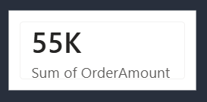
KPI Card
Displays the Total Order Amount, which is approximately 55K.

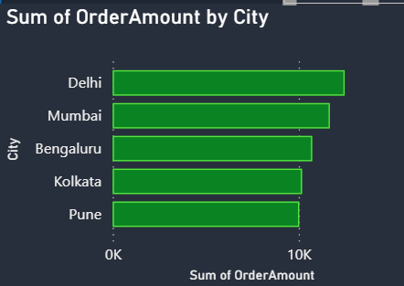
City-wise Sales
A horizontal bar chart compares the total order amount across different cities such as:
- Delhi
- Mumbai
- Bengaluru
- Kolkata
- Pune

This helps identify the highest-performing city.

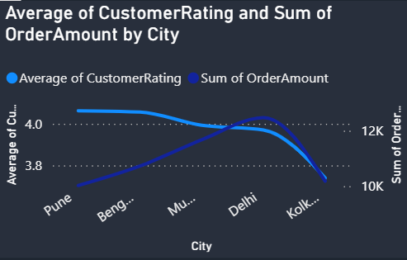
Customer Rating Analysis
A line chart displays:
- Average Customer Rating
- Order Amount by City

This helps compare customer satisfaction with sales performance.

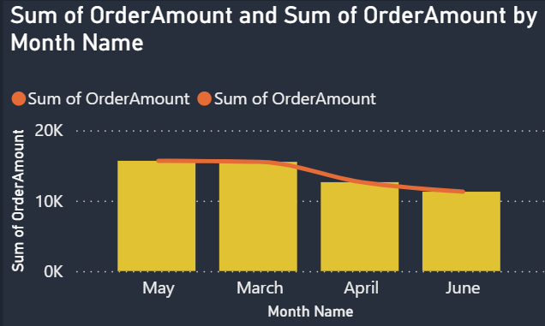
Monthly Sales Trend
A combination chart displays monthly order amounts for:
- March
- April
- May
- June

This helps analyze seasonal sales trends.

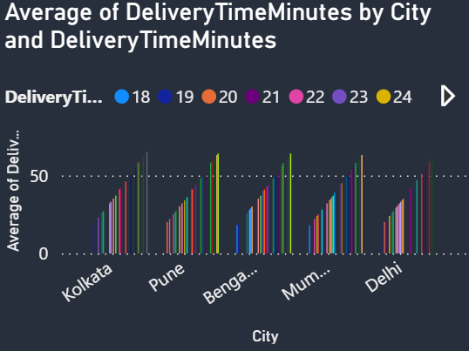
Delivery Time Analysis
A clustered column chart compares average delivery times across cities.
This helps evaluate delivery performance and operational efficiency.

Cuisine-wise Rating Analysis
A bar chart compares the standard deviation of customer ratings for different cuisine types such as:
- Chinese
- Fast Food
- Italian
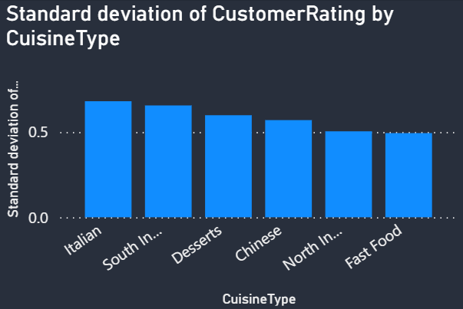
- Desserts
- South Indian
- North Indian

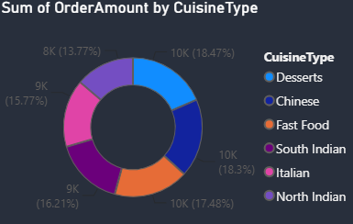
Cuisine Distribution
A donut chart displays total order amount by cuisine type, showing the contribution of each cuisine to total revenue.

Interactive Filters
The dashboard contains multiple slicers for filtering data.

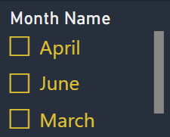
Month Filter
- March
- April
- May
- June

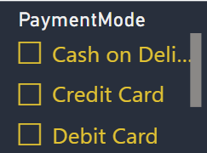
Payment Mode Filter
- Cash on Delivery
- Credit Card
- Debit Card

Cuisine Filter
- Chinese
- Desserts
- Fast Food
- Italian
- North Indian
- South Indian
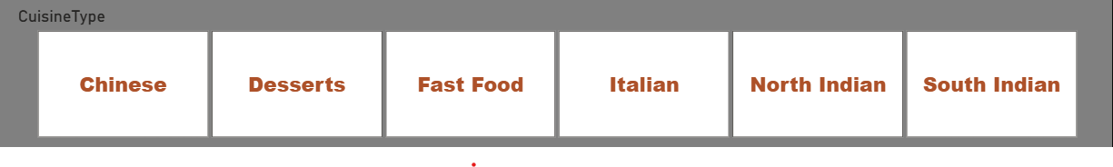

City Filter
- Bengaluru
- Delhi
- Kolkata
- Mumbai
- Pune

Selecting any filter updates all charts automatically.

DEVELOPMENT PROCESS

Step 1: Collected the dataset.
Step 2: Imported the dataset into Power BI.
Step 3: Verified data quality.
Step 4: Checked data types.
Step 5: Created DAX measures.
Step 6: Designed dashboard visuals.
Step 7: Added slicers and filters.
Step 8: Applied Light/Dark mode using bookmarks and the Selection Pane.
Step 9: Tested dashboard interactivity.
Step 10: Finalized the dashboard for submission.

PROBLEMS FACED
During dashboard development, we encountered the following challenges:
- Incorrect data aggregation
- DAX calculation errors
- Visual alignment issues
- Theme formatting
- Bookmark configuration
- Slicer interaction settings

SOLUTIONS
To overcome these issues:
- Corrected aggregation methods.
- Verified DAX formulas.
- Improved dashboard layout.
- Applied consistent formatting.
- Configured bookmarks correctly.
- Tested all slicers and interactions.

OUTPUT
The final dashboard provides an interactive view of food delivery business performance.
It includes:
- Total Revenue KPI (55K)
- Revenue by City
- Monthly Sales Trend
- Customer Rating Analysis
- Delivery Time Analysis
- Cuisine-wise Revenue Distribution
- Interactive Slicers
- Light/Dark Mode Toggle

Dark Mode
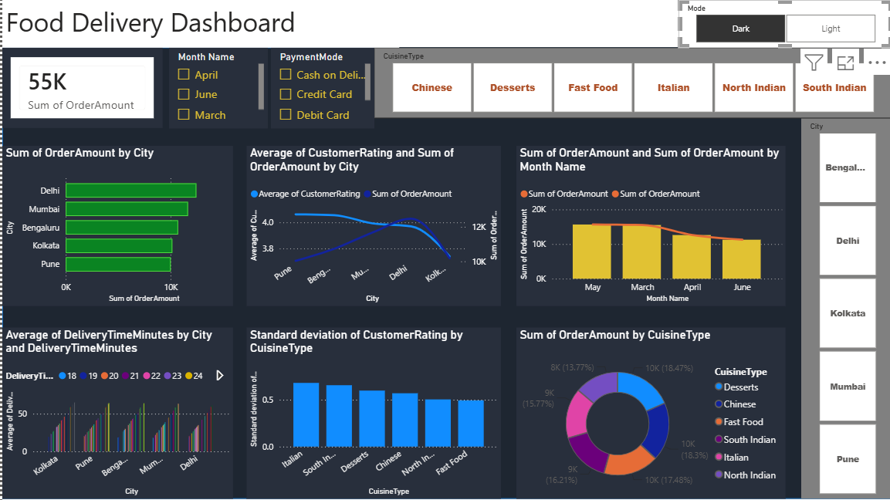
Light Mode
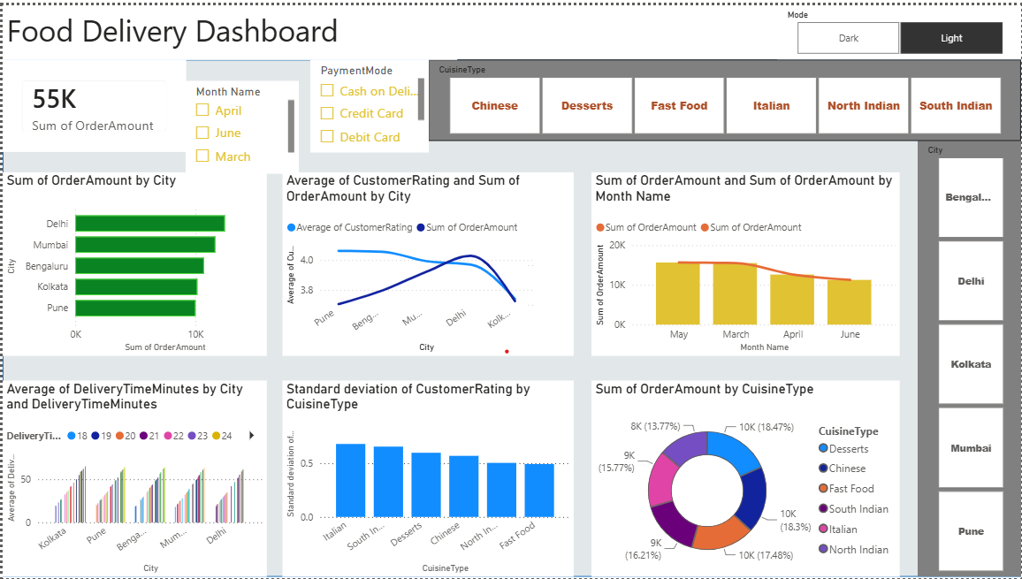
CONCLUSION

The Interactive Food Delivery Dashboard successfully transforms raw food delivery data into meaningful business insights using Microsoft Power BI. The project enhanced our understanding of Power Query, DAX, data visualization, dashboard design, and interactive reporting. The dashboard enables users to analyze sales trends, customer satisfaction, delivery performance, and cuisine preferences efficiently, making it a valuable tool for business decision-making.

This version closely matches the dashboard shown in your screenshot and is suitable for your project report.

